**PROJECT SYNOPSIS**

**ON**

**ZUPER MARKET**

(E-Shopping Website)

**Submitted in the partial fulfillment for the award of the Degree of**

**MASTER OF COMPUTER APPLICATIONS**

**(BATCH 2016-2018)**

**SUBMITTED BY**

**LALIT GIRI**

**ROLL NO: 1621614825**

**UNDER THE SUPERVISION OF**

**MR. SANJAY PUROHIT**

**ASSISTANT PROFESSOR (MCA)**



**IIMT COLLEGE OF ENGINEERING, Gr. NOIDA**

**MAY, 2018**UPTU

UPTU

UPTU

**ACKNOWLEDGEMENT**

I am very grateful to my project guide Mr. Rahul Chauhan for giving his valuable time and constructive guidance in preparing the Project.

It would not have been possible to complete this project in short period of time without his kind encouragement and valuable guidance.

Date:

**Signature**

Lalit Giri

Roll No. :- 1621614825

***INDEX***

1. Introduction
2. Objective of the project
3. Project Category
4. System Analysis
5. Data Flow Diagram
6. ER Diagram
7. Table Structure
8. S/W Requirement
9. Reason For Opting Angular 4, Spring And Hibernate Framework
10. Detail of Modules
11. Future Scope Of Application

***INTRODUCTION***

**“On-Line Shopping System”** is a web-based project which is made for remote-shopping or shopping through Internet. As the technology is being advanced the way of life is changing accordance. Now a day’s we can place the order for anything from our home. There is no need to go the shop of the things we want. The order can be placed online through Internet. The payment, the confirmation of purchasing; we can do everything that we want. Now we can think that how the days have been changed with time. People had to stand in rows to wait there terms to buy a particular thing from a popular shop. But what is happening now a day’s; we can extremely surprise that those things can be available on the door-step in few hours. People had to suffer the rush of the market when they went for shopping. They used to think hundred times to buy anything having the sufficient money for shopping. The problem was the rush; the quarrel at the time of buying the things. But the advancement of technology brought the new way for shopping. The way of shopping was completely changed with the coming of Internet Technology. People have to fill a simple form on the internet to place their order on any popular shop or shopping-mall for the thing they want to buy. Now they can place their order from the home. This project entitled “On-Line Shopping” is an implementation of the above description. It means, it implements the E-shopping or in other word shopping through Internet. It lets the user to place their order online for any article.

***OBJECIVE***

Today the internet and its boom have created a new economic scenario that not only stresses on the classical concept of the “product” but also on the modern concept of “service”. It is this level of service that dictates whether a commercial venture will succeed or not in the market. To provide a high accessibility of service we will design the online shopping website, so that potential customers need not go to a physical shop to buy products or services. There are several objective of this websites are following given below:

* This site is gives all the information about the e-shopping to provide better service for the customer.
* It provides the facility to the customers who want to shop on-line due to lack of time.
* It’s providing the full details about the product and related information about the product like cost, size etc.
* With the help of it we can save the time and money also.
* It provides multiple payment methods for shopping by the cash, Debit card and credit card also.
* It provides better security and good delivery service to the customer.

***PROJECT-CATEGORY***

**Web-Based Application Software with RDBMS:**

This System i.e. “On-Line Shopping” is a web based application software which perform the activities like Administering, providing information to the shopping by the remote system or through internet. The nature of this software to handle a particular task that’s why it is the category of application software.

This project falls under The Category of **Internet Technologies with RDBMS**, since the project is mainly for providing on-line shopping of the different items. This project is utilizing Relational Databases as back-end. Having on-line services for the interested user it has great demand in market. As we know that Internet is huge client-server architecture. The client is a web browser, it is requesting a web based data, a file, or whatever, from the sever staying anywhere in the world. Server is nothing the service provider which provides services to the client. It holds almost all the information that client side wants. I have uses .Net framework to develop the software.Asp.Net is rich set programming framework for building web-based application. It offers amazing support to both developer and administrator.

***SYSTEM ANALYSIS***

**Problem Definition:**

The e-shopping Administrator is the super user and has complete control over all the activities that can be performed. The application notifies the administrator of all shop creation requests, and the administrator can then approve or reject them. The administrator also manages the list of available product categories. The administrator can also view and delete entries in the guestbook.

**Shop Owner:**

Any user can submit a shop creation request through the application. When the request is approved by the Mall Administrator, the requester is notified, and from there on is given the role of Shop Owner. The Shop Owner is responsible for setting up the shop and maintaining it. The job involves managing the sub-categories of the items in the shop. Also, the shop owner can add or remove items from his shop. The Shop Owner can view different reports that give details of the sales and orders specific to his shop. The Shop Owner can also decide to close shop and remove it from the mall.

**Employees:**

Purchase department under a Purchase manager to overlook purchasing activities if warehousing needs arise. Sales department under a Sales manager who will look after the sale of products and services, the most important activity. Accounts department under an Accounts manager to look after the accounting activities of the enterprise.

**Requirement Specification:**

It is quite difficult and time consuming task to find the information as well as maintaining information manually. If all these information are to be kept at a single place it is also not possible in the manual system. Computerized system will upgrade and manage information very easily. As it is a web-based application so it uses Internet technologies and its hardware/software requirement will also be more comprehensive than Desktop application system. Some Network devices will be required like modems, switches, Internet connection. Software required for the system is also different from a normal desktop system. First of all a server software will be mandatory (here Internet Information Server (IIS)). A browser is also needed as a client process on the user side.

**Preliminary Investigation:**

System Analysis is not only time consuming but also a rigorous task. But it is crucial and most important phase of Software development process. Preliminary Investigation is the process of gathering data for requirement analysis. It is more helpful for problem definition and requirement specification.

***Data Flow Diagram***

**DFD Level 0**

Database

Cart Management

View Product

**E-commerce Portal Management**

Admin/ Vendor

Users/ Customers

User Details Management

Product Management

Place Order

Vendor Management

User Management

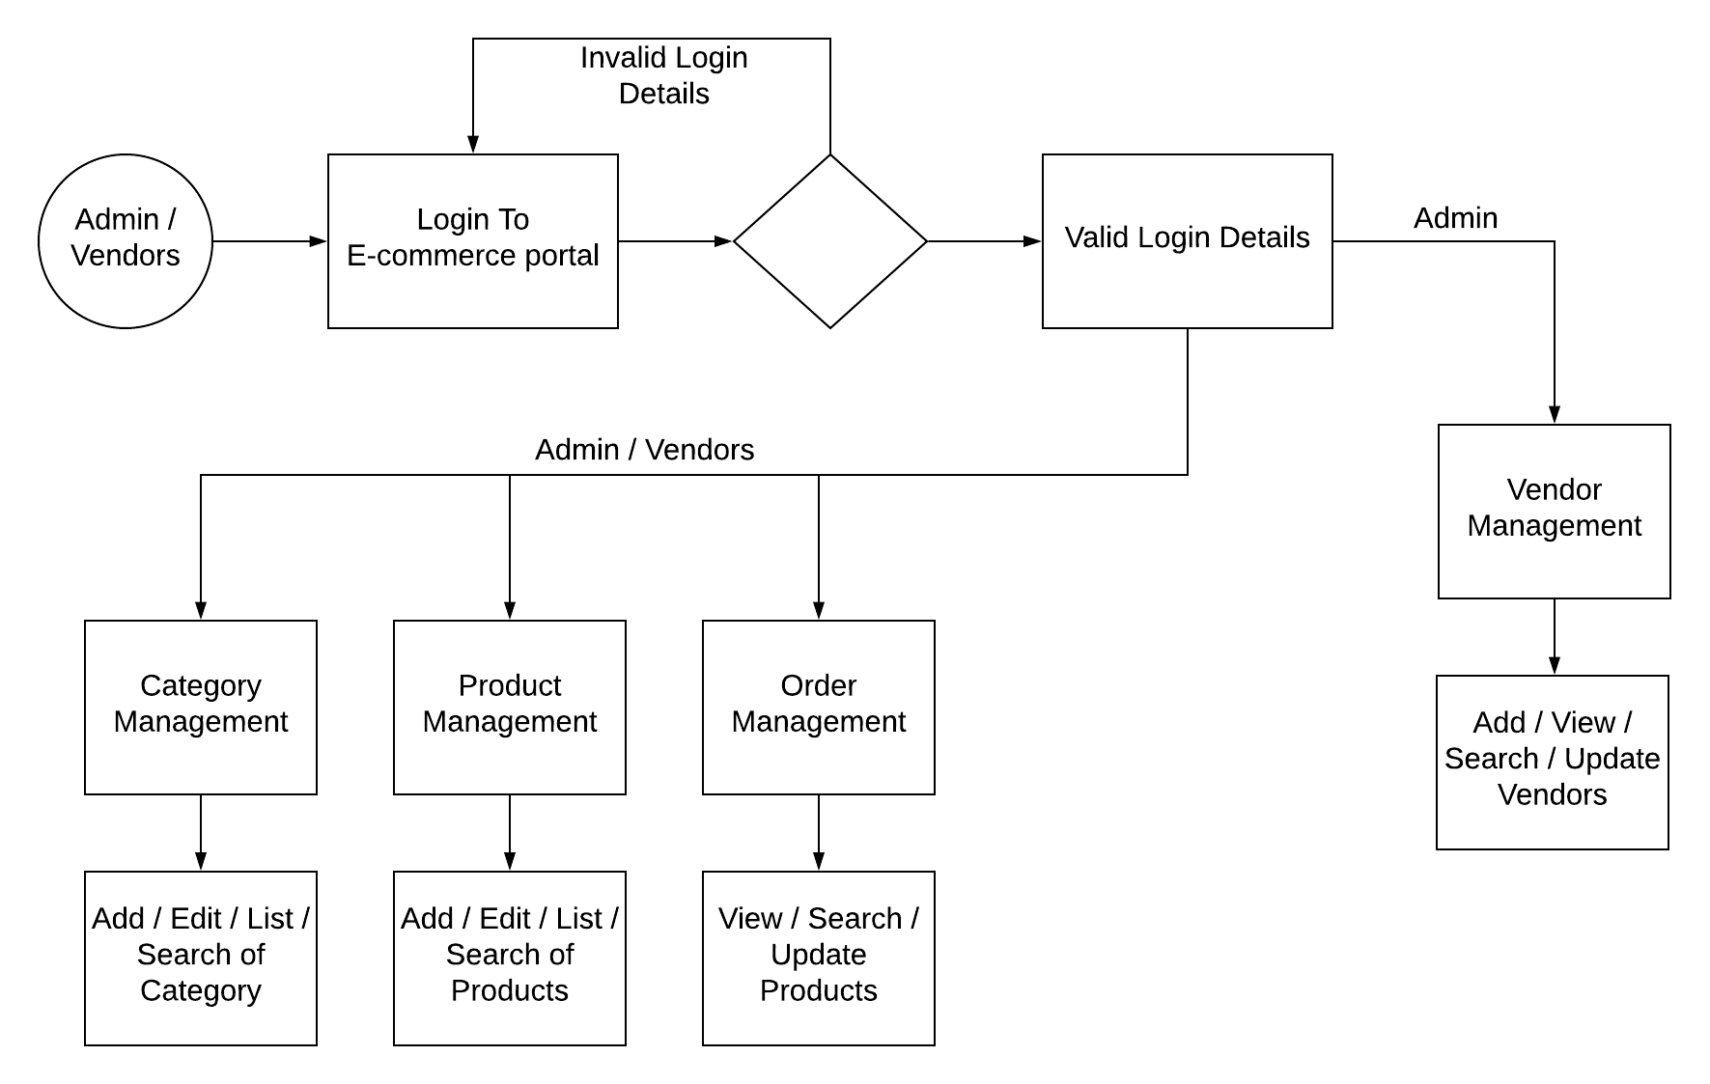**Level 1**

**Level 2**



***ER DIAGRAM***

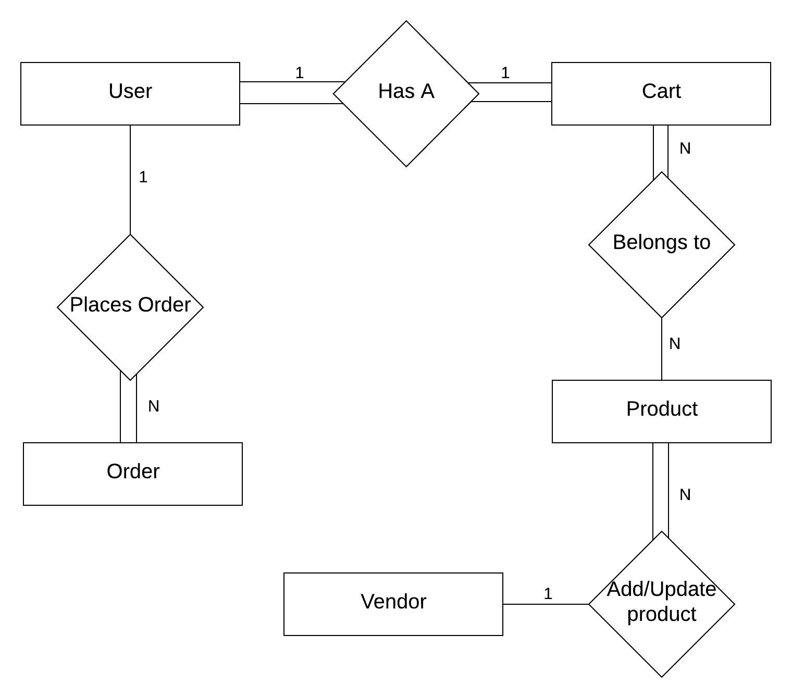

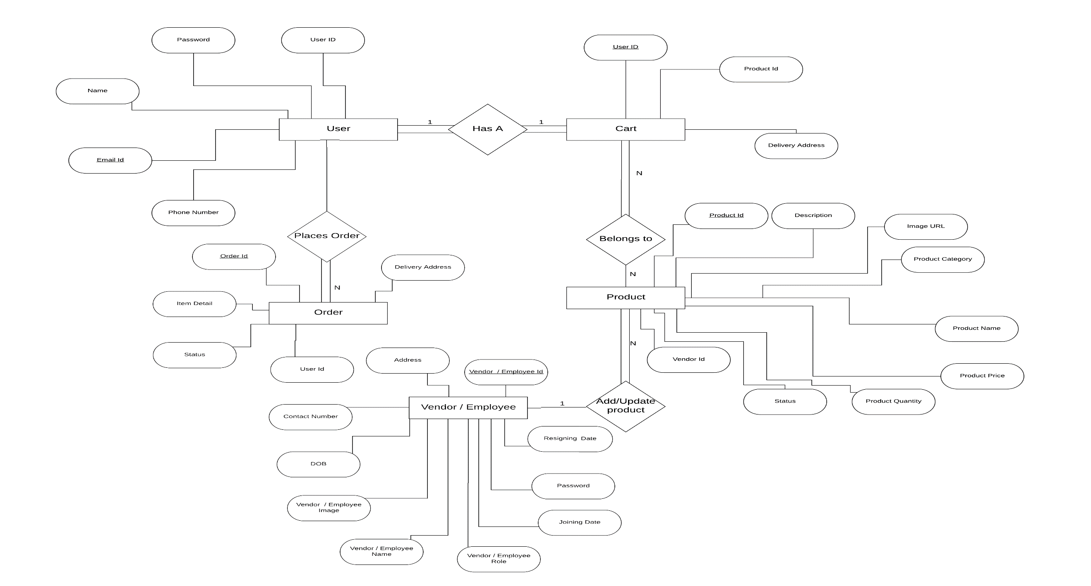

***Table Structure***

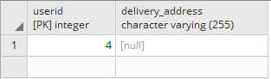

Table 1 Cart Details

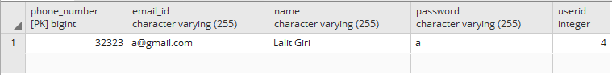

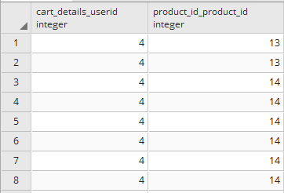

Table 3 Cart_Details_Product_Id

Table 2 User Details Table

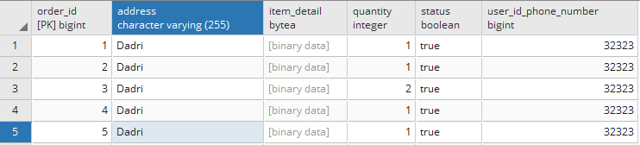

Table 4 Order Details Table

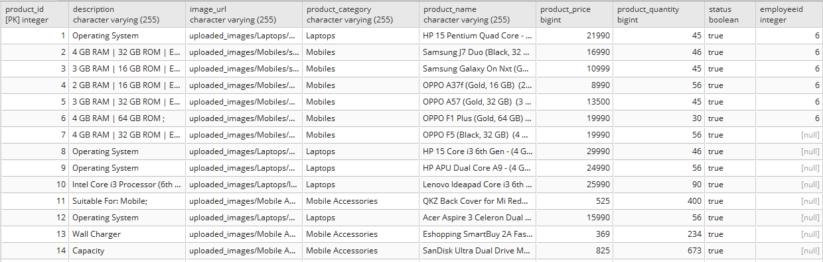

Table 5 Product Details Table

***REQUIREMENT SPECIFICATION***

***Software Requirement***

**Platform :** Web Based

**Framework :** SpringBoot, Hibernate, Angular 4

**Front-End :** HTML, CSS, BootStrap4

**Back-End Tool(DB) :** Postgre Sql

**Ide Tool :** Visual Studio Code, Spring Tool Suit

**Build Tool :** Maven

***REASON FOR OPTING ANGULAR 4, SPRING AND HIBERNATE FRAMEWOK***

**Angular 4** is a JavaScript framework for building web applications and apps in JavaScript, html, and TypeScript, which is a superset of JavaScript. Angular provides built-in features for animation, http service, and materials which in turn has features such as auto-complete, navigation, toolbar, menus, etc. The code is written in TypeScript, which compiles to JavaScript and displays the same in the browser.

**Spring framework** is an open source Java platform that provides comprehensive infrastructure support for developing robust Java applications very easily and very rapidly. Spring help to make the layered architecture of the application that makes the modules of application loosely coupled.

**Hibernate** is a high-performance Object/Relational persistence and query service, which is licensed under the open source GNU Lesser General Public License (LGPL) and is free to download. Hibernate not only takes care of the mapping from Java classes to database tables (and from Java data types to SQL data types), but also provides data query and retrieval facilities.

***MODULE DESCRIPTION***

We know that it is quite difficult to do anything of its whole part at a time. So it is the task of the programmer to break/split the whole set of task into various small module so that one can handle them effectively. But it depends upon the software system that in which Extent it will be broken so that there is no inter-dependency among them.

This project developed for “On-Line Shopping” is broken into following module.

1. Admin Module

2. User Module

3. Customer Service Module

4. Payment Module

5. Purchase Module

6. Searching Module

**ADMIN MODULE:**

Admin module is mainly for the owner of the system. This module performs the work of regular checking process. Everyone needs current information about anything. So, this module is responsible for updating the information continuously if any, in the system so that one can find timely information. But the main function of this module is to handle security of this system. Different types of authentication and authorization process is performed for this purpose. This module is also responsible for advertisement bid. Any organizations that are eager for advertisement can contact us for their ad. This module handles the entire task related to advertisement like specifying and allocating the space and related cost.

**USER MODULE:**

User module is the front page of this system. It is the main page of the system in which all the links of this system are kept. Now the main thing is how to make the home page interactive and user friendly so that there should not be any problem for the user. This is the task of the system administrator to make the home page Interactive.

**CUSTOMER SERVICE MODULE:**

In the customer service module, the customer will use this website to on-line shopping. And also the customer send the request to the shopping.

**PAYMENT MODULE:**

In this module, the customer will make payment in different mode like cash on delivery, or by credit card, or by debit card.

**PURCHASE MODULE:**

In this module, the all selected item could be purchased by the customer. And will do payment.

**SEARCH MODULE:**

Search module provides search facilities to the search different product to the purchase.

***FUTURE SCOPE OF THE PROJECT***

“On-Line Shopping” is a web-based project which is made for remote-shopping or shopping through Internet. As the technology is being advanced the way of life is changing accordance. Now a day’s we can place the order for anything from our home. There is no need to go the shop of the things we want. The order can be placed online through Internet. The payment, the confirmation of purchasing; we can do everything we want. Now we can think that how the days have been changed with time. People had to stand in rows to wait there terms to buy a particular thing from a popular shop. But what is happening now a day’s; we can extremely surprise that those things can be available on the door-step in few hours. In future we will try to make this website which work so flexible and beneficial for the customer and also try to make smooth service.